ANALYSE OF REDDIT 2013-01-07

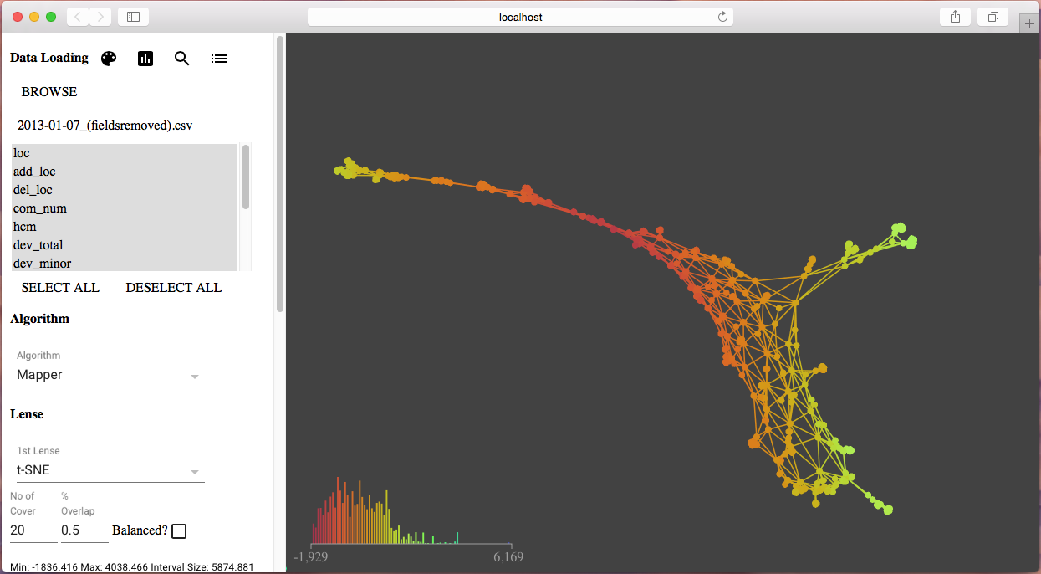

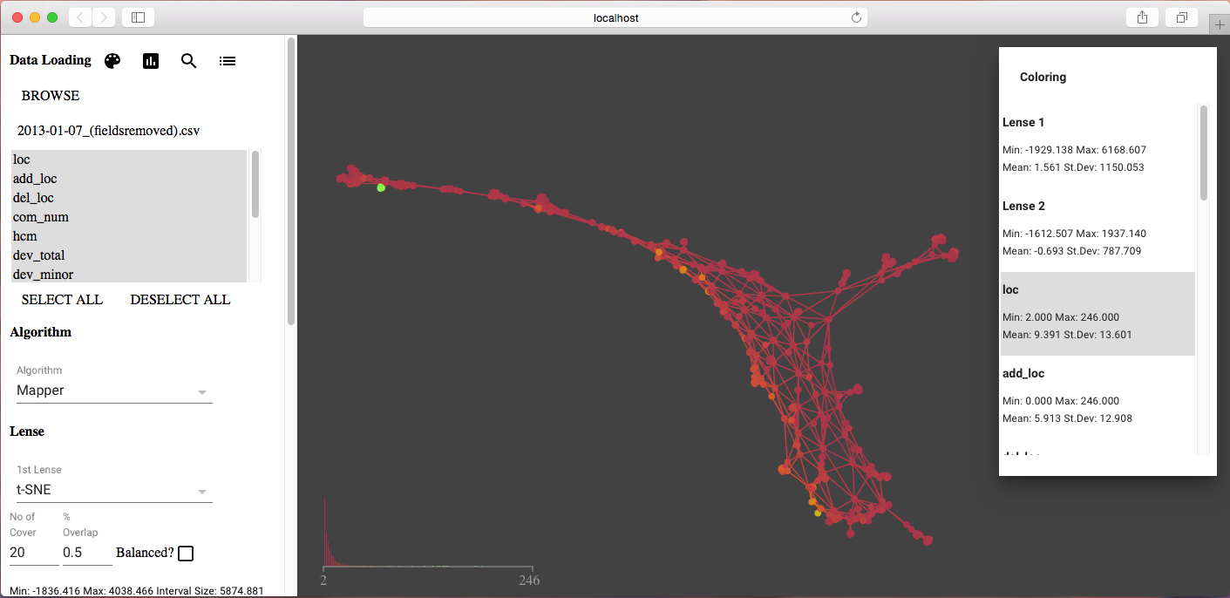

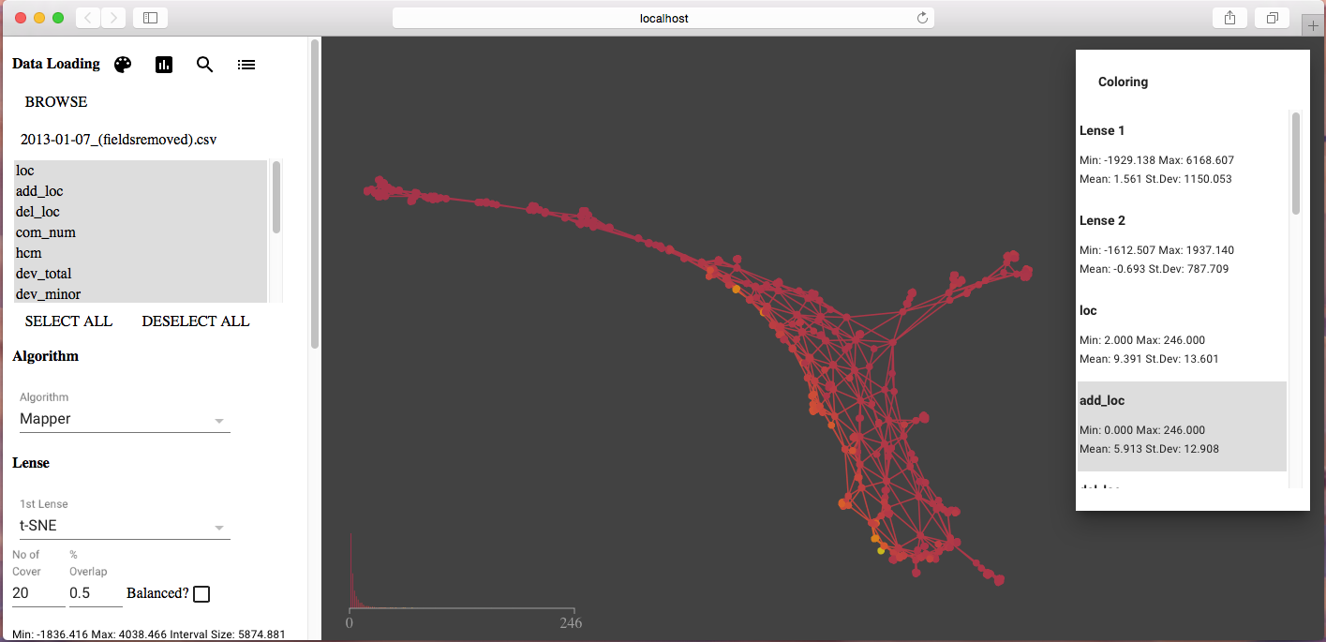

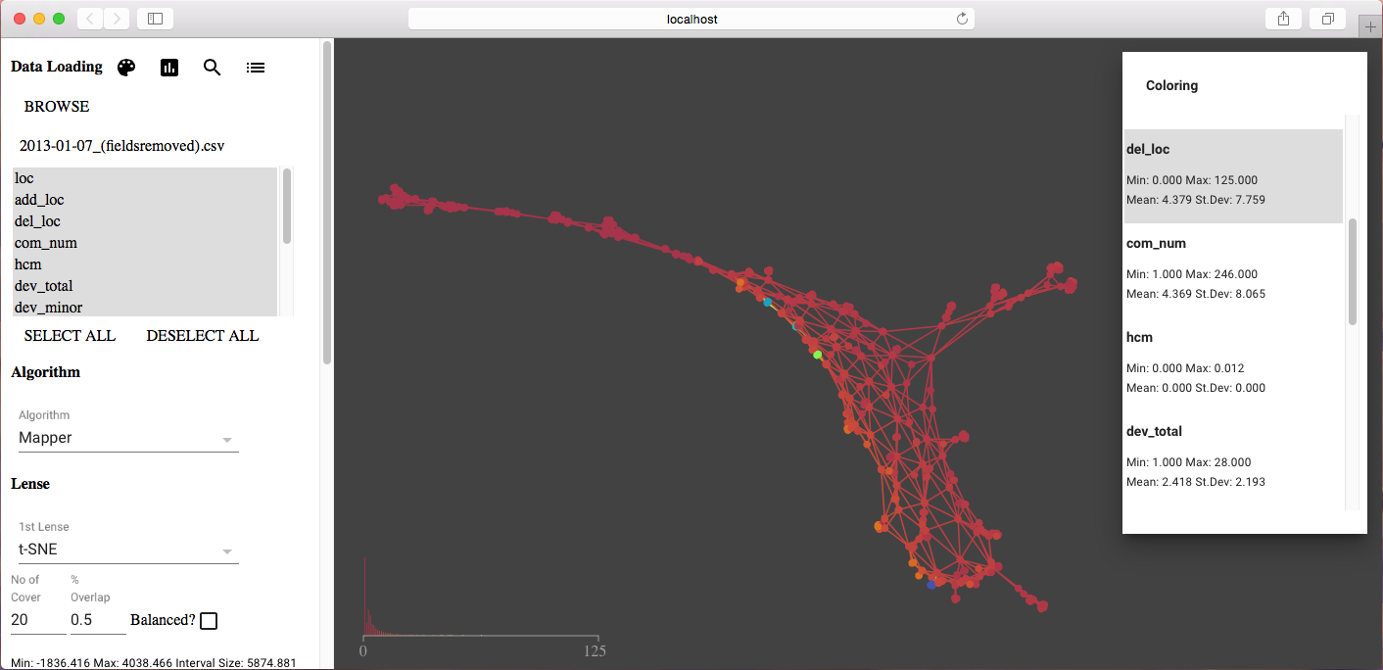

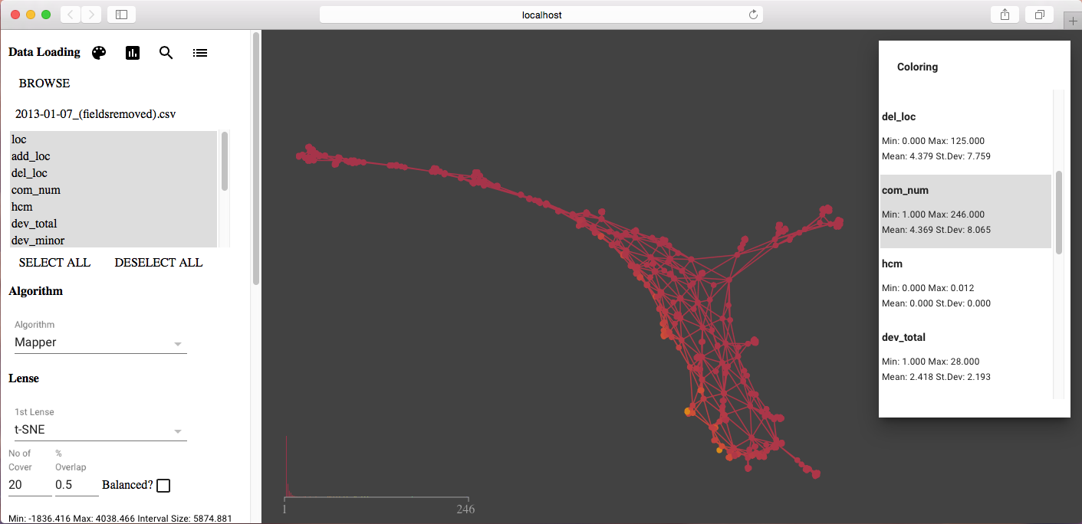

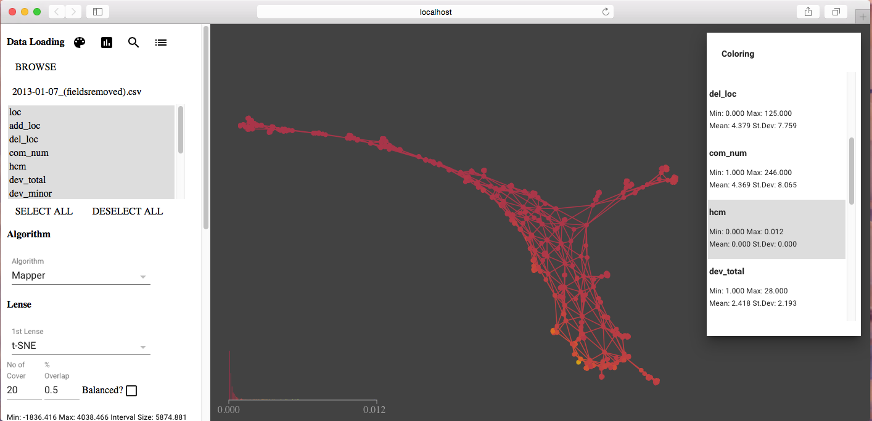

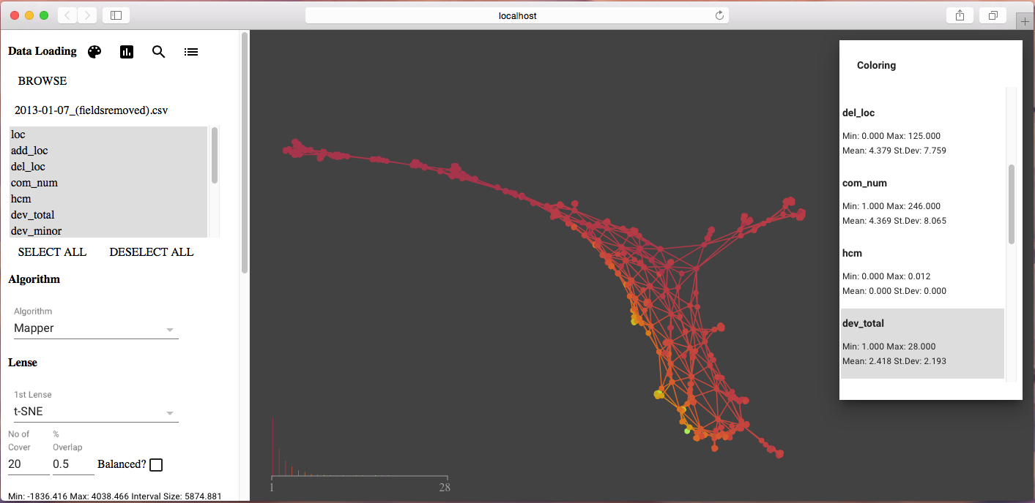

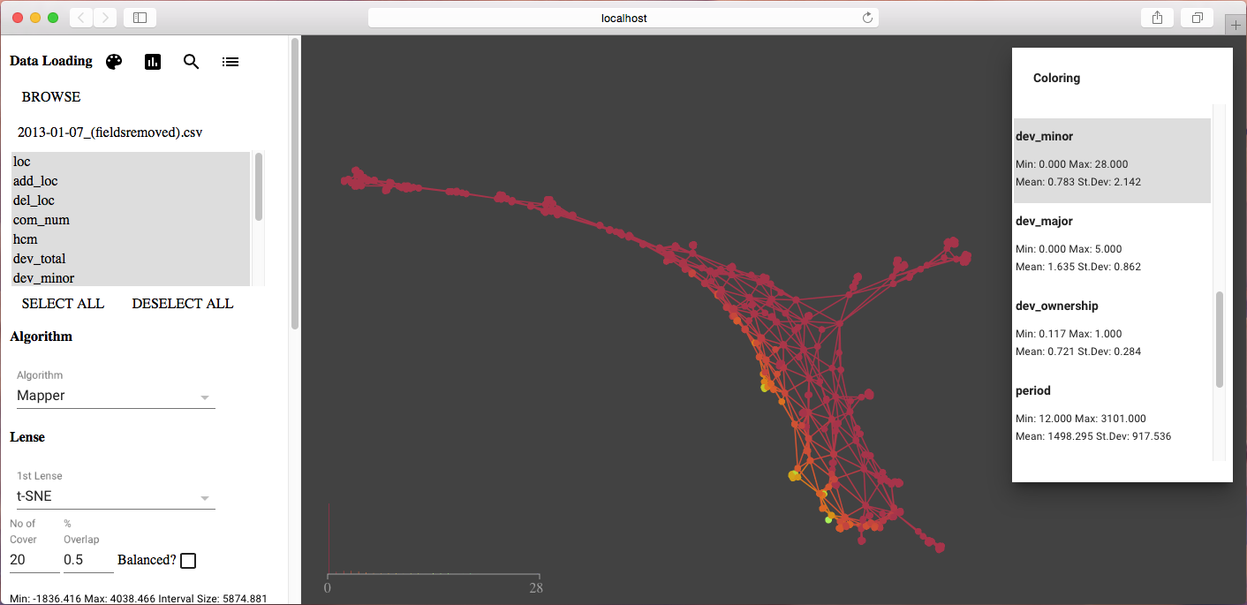

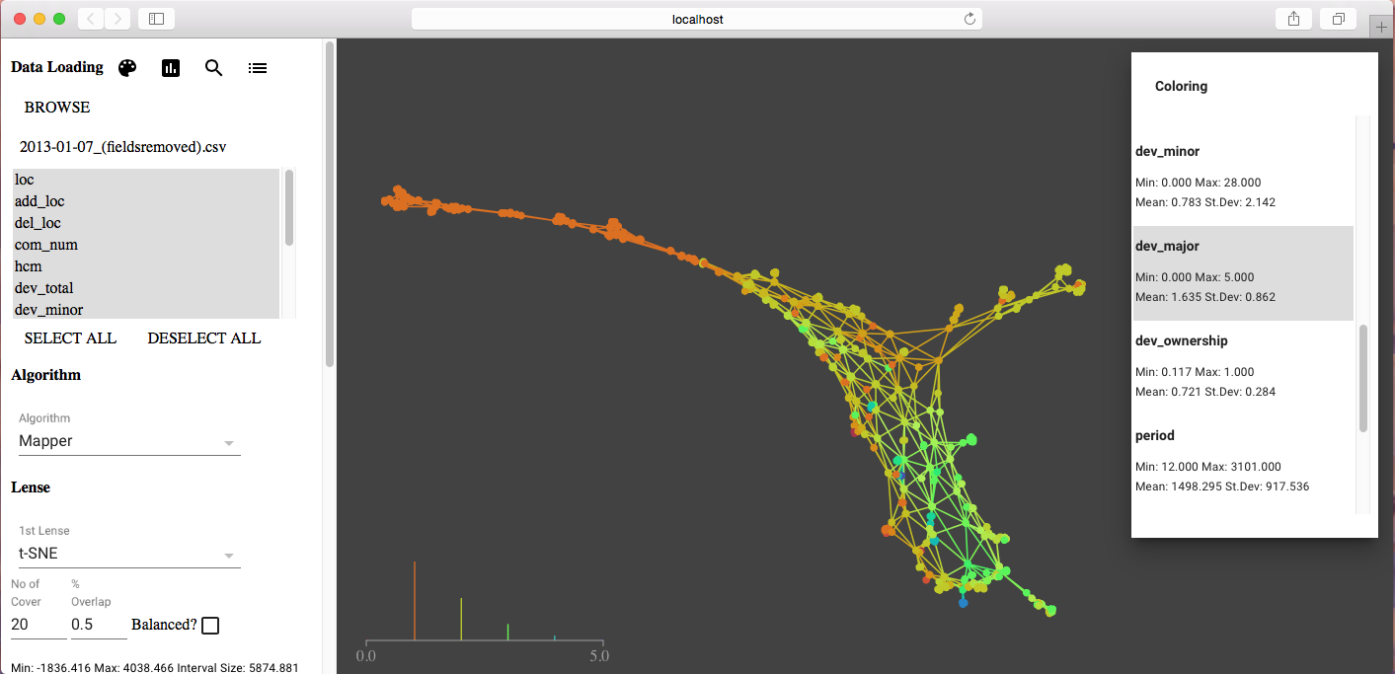

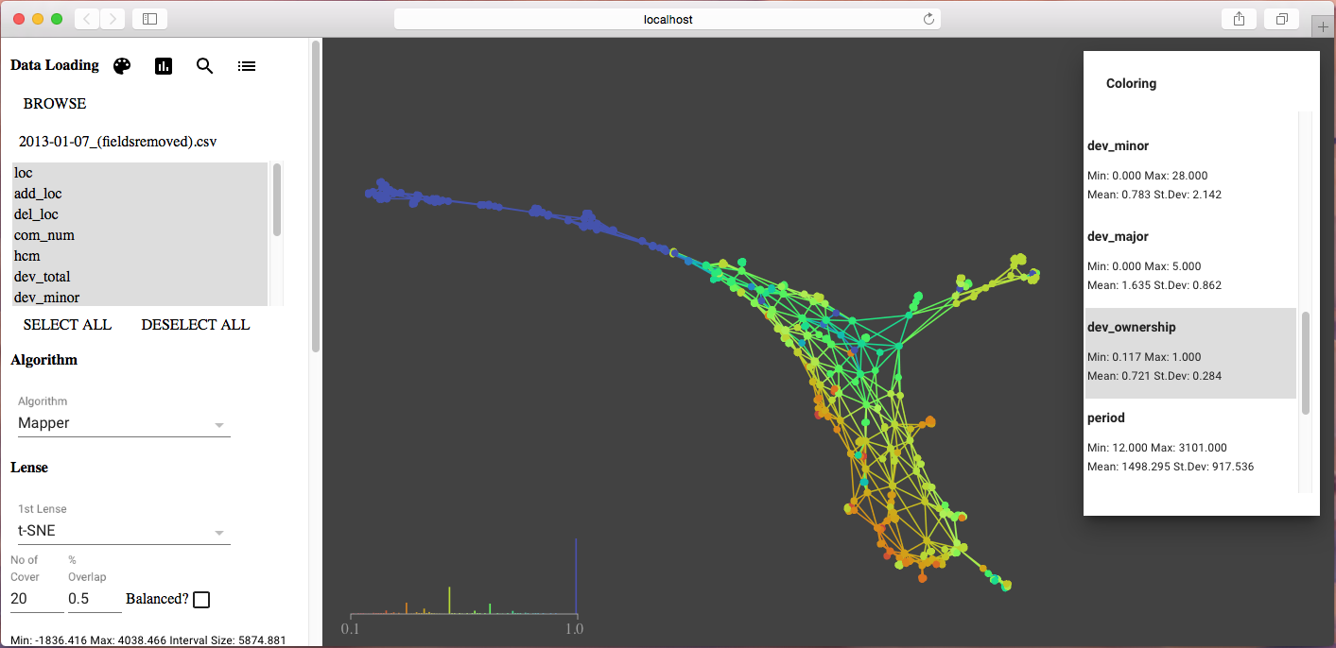

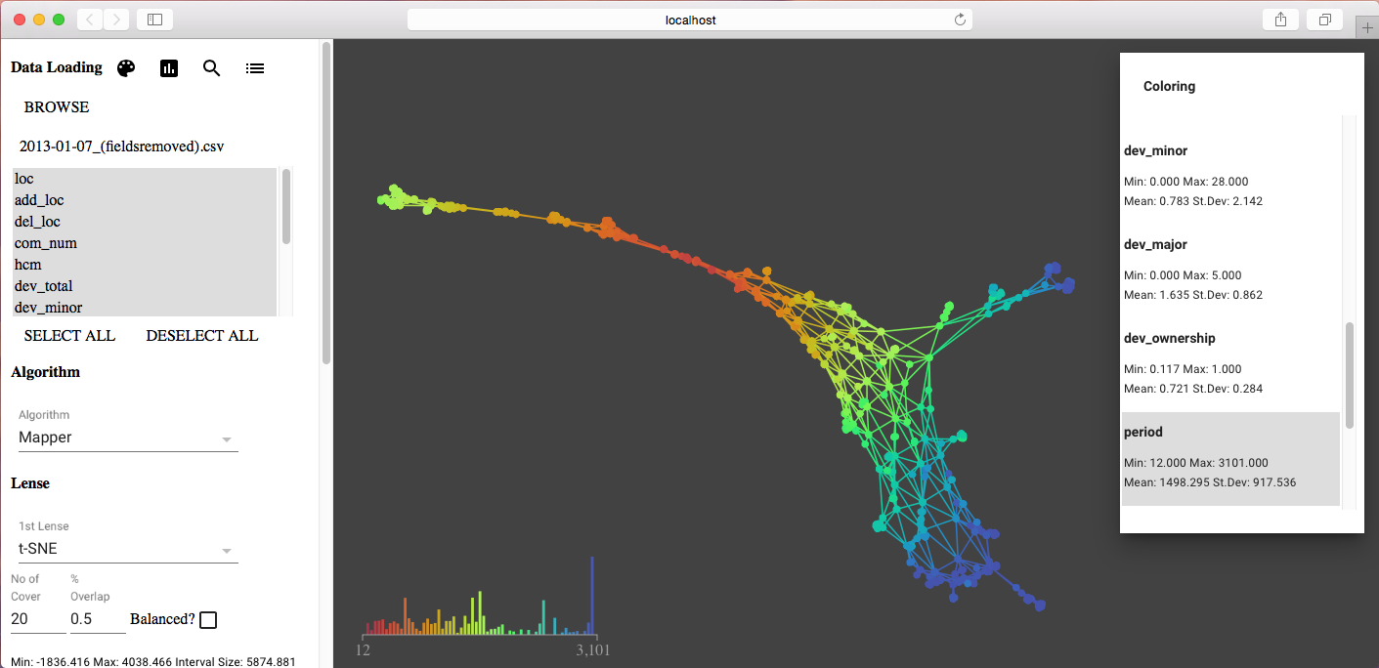

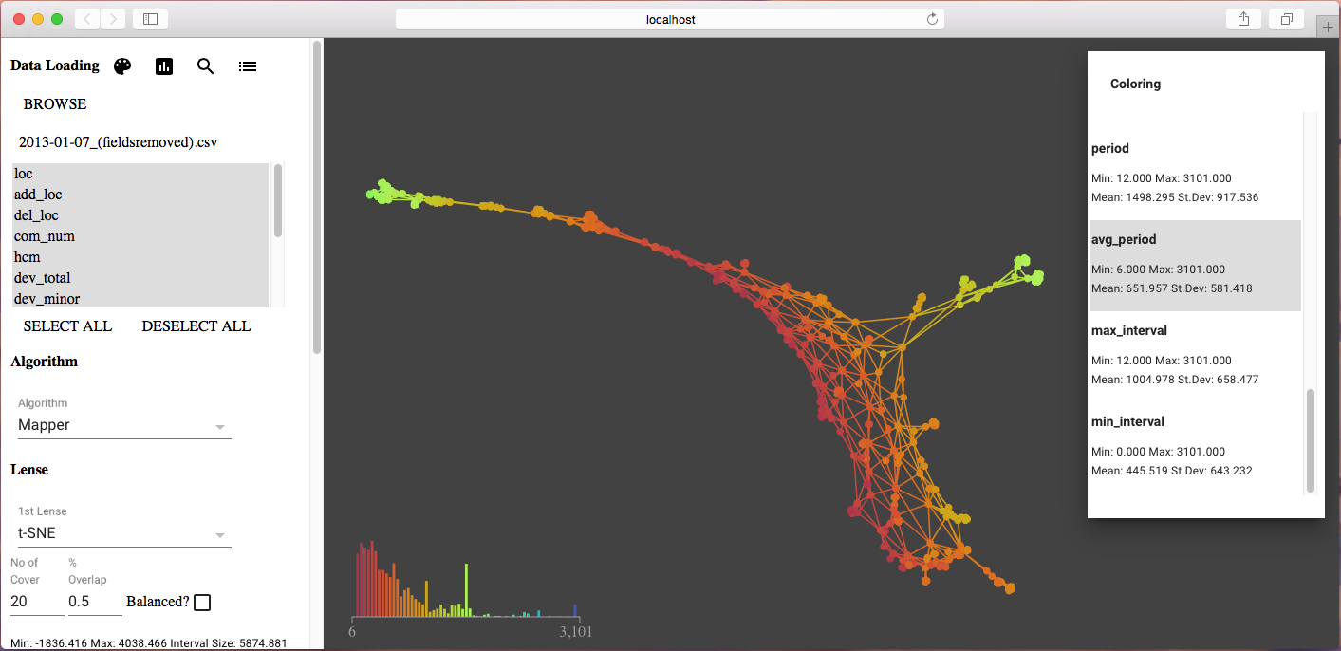

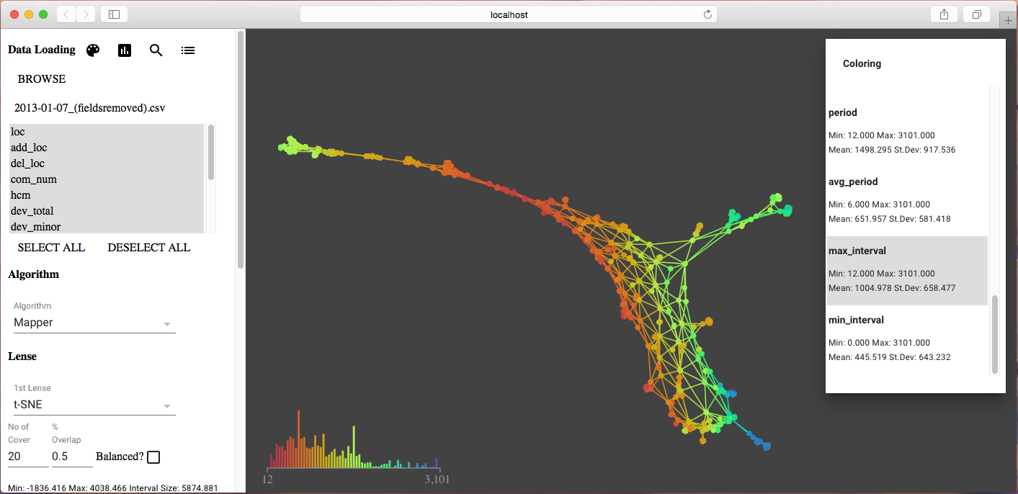

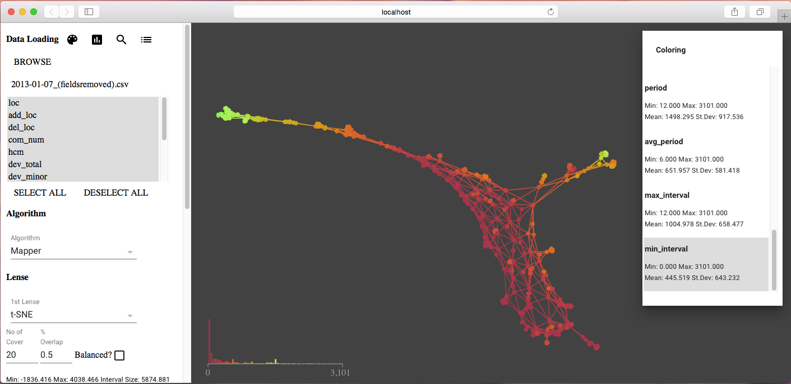

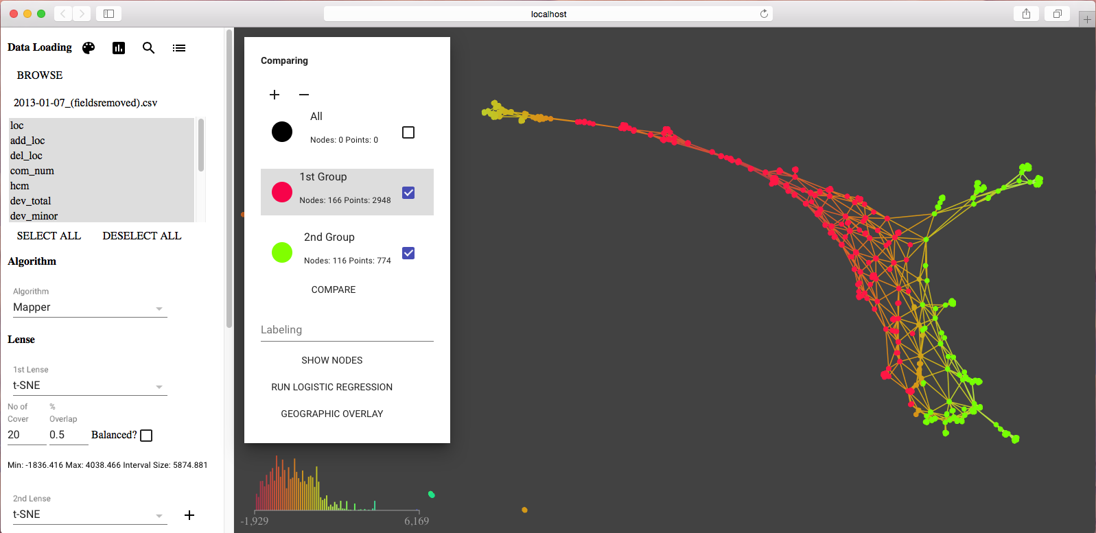

#### Analysis Result

|  |  |  |  |  |  |  |  |  |
| --- | --- | --- | --- | --- | --- | --- | --- | --- |
| **Variables** | **Group 1 min** | **Group 2 min** | **Group 1 mean** | **Group 2 mean** | **Group 1 median** | **Group 2 median** | **Group 1 max** | **Group 2 max** |
| loc | 2.0 | 2.0 | 9.311 | 9.061 | 6.0 | 5.0 | 106.0 | 76.0 |
| add_loc | 0.0 | 0.0 | 5.746 | 8.081 | 3.0 | 4.5 | 95.0 | 69.0 |
| del_loc | 0.0 | 0.0 | 4.511 | 6.526 | 2.0 | 3.0 | 106.0 | 125.0 |
| com_num | 1.0 | 2.0 | 3.871 | 6.894 | 2.0 | 5.0 | 74.0 | 44.0 |
| hcm | 0.0 | 0.0 | 0.0 | 0.001 | 0.0 | 0.001 | 0.003 | 0.003 |
| dev_total | 1.0 | 1.0 | 2.252 | 3.904 | 2.0 | 3.0 | 16.0 | 19.0 |
| dev_minor | 0.0 | 0.0 | 0.611 | 1.734 | 0.0 | 0.0 | 16.0 | 19.0 |
| dev_major | 0.0 | 0.0 | 1.641 | 2.171 | 1.0 | 2.0 | 5.0 | 5.0 |
| dev_ownership | 0.158 | 0.143 | 0.731 | 0.464 | 0.75 | 0.455 | 1.0 | 1.0 |
| period | 12.0 | 1689.0 | 1060.971 | 2838.795 | 987.0 | 3038.0 | 2877.0 | 3101.0 |
| avg_period | 6.0 | 68.0 | 401.829 | 663.734 | 341.5 | 620.0 | 1067.0 | 1550.0 |
| max_interval | 12.0 | 422.0 | 685.958 | 1532.087 | 623.0 | 1565.0 | 1883.0 | 2877.0 |
| min_interval | 0.0 | 0.0 | 229.046 | 166.694 | 89.0 | 33.5 | 1067.0 | 1546.0 |